**Taks 1: Business Problems**

1. **High IT Infrastructure and Maintenance Costs**

**Problem Description:**

Bintoso is spending a significant portion of its budget on IT infrastructure, including data center leases and hardware refreshes, which is contributing to margin pressures as noted by the CEO, Simone Warel​

**Cloud Solution:**

Migrating to a cloud-based infrastructure could significantly reduce these costs. Cloud services typically offer a pay-as-you-go model, eliminating the need for costly hardware investments and the associated maintenance. This shift can also streamline budgeting and reduce capital expenditures, as operational expenses can be scaled up or down based on current business needs. This flexibility is especially beneficial for Bintoso, which experiences fluctuating demands and needs to quickly adapt to market changes.

1. **Scalability and Performance Issues**

**Problem Description:**

Bintoso's online site, particularly for European customers, suffers from slow performance​​. Additionally, the site's 3-tier architecture struggles to meet the growing online demands, affecting user experience and potentially sales during peak times, such as the holiday seasons when an outage occurred due to infrastructure limitations​​.

**Cloud Solution:**

Cloud computing offers scalable resources that can adjust in real-time to meet the demands of Bintoso's online traffic and performance requirements. By leveraging cloud services, Bintoso can ensure that their e-commerce platform can handle peak loads with ease by automatically scaling up resources when needed and scaling down during off-peak times. This will not only improve the customer experience but also optimize costs associated with server maintenance and energy consumption.

1. **Data Security and Compliance**

**Problem Description:**

Bintoso experienced a significant security breach in one of their data centers (DC1), which damaged their brand reputation​​. The need for enhanced security measures is clear, especially with the company's expansion into online services and the storing of sensitive customer data.

**Cloud Solution:**

Moving to a cloud platform can improve security by providing advanced security features that may be too costly or complex for Bintoso to implement on-premises. Cloud providers typically offer robust security measures, including regular updates, threat detection, multi-factor authentication, and data encryption, which can help protect against data breaches. Additionally, cloud services often comply with various international and industry-specific standards, helping Bintoso meet compliance requirements more efficiently.

By addressing these problems with cloud-based solutions, Bintoso can not only improve operational efficiency and security but also potentially enhance customer satisfaction and competitive positioning in the digital market.

**Task 2**: see workload-to-dc-map.xlsx

**Task 3:**

**Question 1: Key Risks of Embarking on a Cloud Journey without a Governance Model**

**Cost Management and Budget Overrun:** Without a cloud governance model, Bintoso may face challenges in tracking and controlling cloud spending. The pay-as-you-go model of cloud services, while flexible, can lead to unexpected expenses if not monitored closely.

**Security and Compliance Risks:** The absence of a structured governance framework can result in inadequate security controls and compliance measures. This is particularly risky for Bintoso given the security breach in their Las Vegas Datacenter and the need to protect sensitive customer information.

**Resource Mismanagement:** Without clear policies and governance, there can be inefficient use of cloud resources, leading to wastage. This includes poorly managed resource allocation, underutilized services, or redundant services that contribute to increased costs and complexity.

**Operational Disruption and Inefficiency:** Migrating to the cloud without a governance model might lead to inconsistencies in operations, affecting the reliability and performance of critical applications like the e-commerce site and Intelli-Robe system. This can degrade user experiences and impact sales.

**Question 2: Virtual Team Structure to Mitigate a Specific Risk**

Chosen Risk: **Security and Compliance Risks**

**Virtual Team Structure: Cloud Security Governance Team**

To mitigate security and compliance risks, a Cloud Security Governance Team would be crucial. This virtual team should include roles such as a Cloud Security Officer, Compliance Officer, Network Security Specialists, and Application Security Professionals. They would report to the Chief Information Security Officer (CISO) and work closely with the Chief Digital Officer (CDO) and VP of IT Operations.

To align with the course concepts and effectively address the governance needs during Bintoso's cloud transformation, a powerful virtual team structure known as a Cloud Center of Excellence (CCoE) is recommended. This structure will be central in managing and mitigating key risks associated with cloud adoption, providing a cohesive approach to governance across various domains such as DevOps, FinOps, security, and compliance.

### **Virtual Team Structure: Cloud Center of Excellence (CCoE)**

Purpose: The CCoE serves as a central governance body that drives cloud adoption strategies, ensuring alignment with business goals while managing risks. It promotes the standardization of cloud technologies and practices, offering guidance, and sharing best practices across the organization.

Key Stakeholders:

* CIO (Chief Information Officer)
* CDO (Chief Digital Officer)
* CISO (Chief Information Security Officer)
* CFO (Chief Financial Officer)
* VP of IT Operations
* Compliance Officer
* DevOps Manager
* FinOps Manager

### **Key Risks and Mitigation Strategies**

Identified Risks:

1. Cost Management and Budget Overrun
2. Security and Compliance Risks
3. Resource Mismanagement
4. Operational Disruption and Inefficiency

### **Focus on Mitigating Security and Compliance Risks**

How the CCoE Addresses This Risk:

1. Establishing Security and Compliance Frameworks:
   * The CCoE develops and implements comprehensive security policies and compliance frameworks tailored to cloud environments. This includes data protection standards, access controls, and regular compliance audits to ensure adherence to laws and regulations like GDPR.
2. Integrating Security Tools and Practices:
   * Under the governance of the CCoE, integrated security tools and practices are deployed across cloud services. This includes unified threat management systems, encryption practices, and identity management solutions that span across all cloud deployments to maintain a robust security posture.
3. Regular Training and Awareness Programs:
   * The CCoE coordinates regular training sessions and awareness programs for all employees involved in cloud operations. This ensures that all team members are aware of the latest security practices and compliance requirements, significantly reducing the risk of human error leading to security breaches.
4. Incident Response and Continuity Planning:
   * The CCoE oversees the development of incident response plans and business continuity strategies. This proactive approach ensures that Bintoso can quickly respond to security incidents and maintain operations with minimal disruption, safeguarding customer data and company assets.

### **Document Inclusion:**

The document elaborating on the CCoE's role in addressing these risks should detail the governance structure, specific responsibilities of each role within the CCoE, and how it interacts with other parts of the organization. It should include examples of best practices for cloud security and compliance established by leading organizations, adapted to fit Bintoso’s specific needs. The document should also propose a timeline for the CCoE’s rollout and milestones for assessing its impact on cloud governance and risk management.

By centralizing cloud governance through a CCoE, Bintoso can ensure that its cloud migration is strategic, secure, cost-effective, and aligned with its broader digital transformation objectives. This approach not only addresses immediate risks but also establishes a framework for continuous improvement and innovation in cloud management.

**Task 4:**

**Virtual Team Structure 1: Cloud Transformation Steering Committee**

**Key Stakeholders:** CEO (Simone Warel), CIO (Muhammad Arya), CDO (Perez Soto), CFO (Koichi Pona), VP of IT Operations (Syed Bhatt), VP of Infrastructure (Alfredo Figueroa), and the Enterprise Architect (Dominique Crawford).

**Purpose**: The Cloud Transformation Steering Committee would serve as the strategic decision-making body overseeing the cloud migration initiative. This committee is responsible for setting the vision for cloud adoption, aligning it with the business's strategic objectives, and ensuring that it supports Bintoso’s digital transformation goals. They would prioritize projects, manage high-level risks, approve budgets, and monitor the overall progress of the cloud transformation. Regular updates and feedback from this committee would help ensure that the cloud strategy remains aligned with the business's evolving needs and market conditions.

**Virtual Team Structure 2: Cloud Operations and Integration Team**

**Key Stakeholders:** VP of IT Operations (Syed Bhatt), VP of App Development (Isa Anthony), Data Architect (Riley Doyle), Security Architect (Elen Feldspar), and representatives from the Application and Infrastructure Operations teams.

**Purpose**: The Cloud Operations and Integration Team would be tasked with the operational management of cloud environments and the integration of cloud solutions into Bintoso’s existing IT infrastructure. This team’s primary focus is to ensure that cloud deployments are optimized for performance and cost, data migration is secure and efficient, and that all cloud services are well-integrated with the on-premises systems to support seamless operations and data flow. They would also handle the day-to-day management of cloud resources, including performance monitoring, cost tracking, and compliance with security policies, facilitating a smooth operational transition to the cloud.

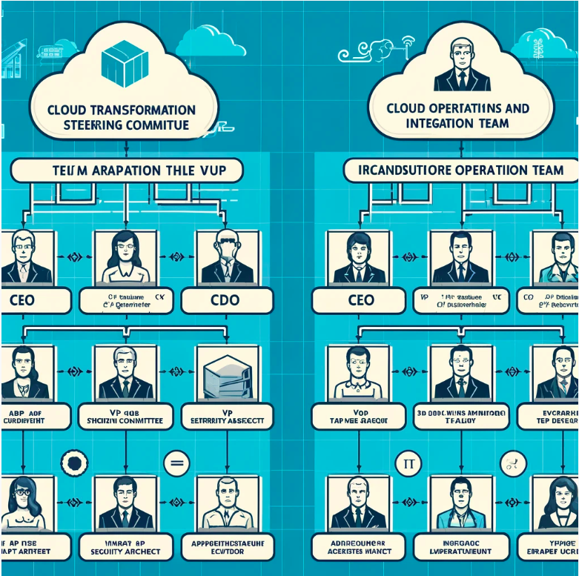

Here are the visual representations of the two organizational charts for Bintoso's virtual team structures:

1. Cloud Transformation Steering Committee - This chart outlines the hierarchical structure from the CEO to other key stakeholders involved in the strategic oversight of cloud transformation.
2. Cloud Operations and Integration Team - This chart shows the organization of the team responsible for the operational management and integration of cloud technologies within Bintoso.

**Task 5:**

**Question 1: Core Elements of Bintoso’s Culture that Need to Change**

**Element 1**: Resistance to Rapid Change

**Evidence and Justification:** Bintoso has a history of being late to adopt digital transformations, indicating a culture that resists rapid change. The company only recently started its digital transformation journey and is already facing challenges keeping up with competitors who have more advanced digital strategies​​. This resistance to change could hinder the agile deployment and iterative improvement required in a cloud-based environment.

**Element 2:** Hierarchical Communication

**Evidence and Justification:** Bintoso's communication is highly formal and hierarchical, with interactions typically occurring through established chains of command (VP to VP, Manager to Manager)​​. This could slow down decision-making processes and impede the cross-functional collaboration essential for effective cloud adoption and agile responses to technological changes.

**Element 3:** Risk Aversion

**Evidence and Justification:** Bintoso’s IT organization has strict formal processes for change management, rewarding stability over innovation​​. While stability is crucial for certain aspects of retail operations, an overly cautious approach can prevent the experimentation and fast-failing methods needed for digital innovation and cloud integration.

**Question 2: Specific Actions to Drive Cultural Changes**

**For Resistance to Rapid Change:**

**Action:** Implement a company-wide agile training program. Focus on educating all levels of the organization on the benefits of agile methodologies, which emphasize flexibility, rapid iteration, and responsiveness to change. This training will help employees understand how adopting these principles can lead to better outcomes in a cloud environment.

**For Hierarchical Communication:**

**Action:** Introduce cross-functional teams and regular inter-departmental meetings that encourage open dialogue and collaboration across different levels of the organization. These teams should be tasked with specific cloud adoption objectives and empowered to make decisions, helping to break down silos and speed up the communication process.

**For Risk Aversion:**

**Action:** Establish a controlled environment where teams can experiment with new cloud technologies without the risk of affecting the entire business. This could include setting up innovation labs or pilot programs that allow employees to test and learn from new technologies in a low-stakes setting, promoting a culture of innovation and calculated risk-taking.

**Task 6:**

### **Roles Under the CIO (Muhammad Arya):**

1. VP of IT Operations (Syed Bhatt)
   * Mapping: Cloud Infrastructure, Cloud Security
2. VP of App Development (Isa Anthony)
   * Mapping: Cloud Applications Infrastructure
3. VP Infrastructure (Alfredo Figueroa)
   * Mapping: Cloud Infrastructure
4. Enterprise Architect (Dominique Crawford)
   * Mapping: Cloud Business Management, Cloud Infrastructure, Cloud Applications Infrastructure
5. Data Architect (Riley Doyle)
   * Mapping: Cloud Applications Infrastructure
6. Application Architect (Hiroko Tanaka)
   * Mapping: Cloud Applications Infrastructure
7. Technology Architect (Doria Gilabert)
   * Mapping: Cloud Infrastructure, Cloud Applications Infrastructure
8. Security Architect (Elen Feldspar)
   * Mapping: Cloud Security
9. Compute Engineer (Nishay Phillips)
   * Mapping: Cloud Infrastructure
10. Storage Engineer (Isabel Aguinaldo)
    * Mapping: Cloud Infrastructure
11. Networking Engineer (Richard Harris)
    * Mapping: Cloud Infrastructure
12. Infrastructure Ops (Petya Gusev)
    * Mapping: Cloud Infrastructure
13. Application Ops (Fatima Patel)
    * Mapping: Cloud Applications Infrastructure

### **Roles Under the CFO (Koichi Pona):**

1. Finance Controller (Xun Tai)
   * Mapping: Cloud Business Management

**Task 7:**

### **Business Innovation Idea: Real-Time Personalized Shopping Experience**

**Idea Description:**

Bintoso can leverage cloud capabilities to create a real-time personalized shopping experience for its customers, both online and in-store. By utilizing cloud-based big data analytics and machine learning, Bintoso can analyze customer behavior, preferences, and past purchases in real time to offer personalized recommendations and promotions. For instance, when a customer interacts with the Intelli-Robe system in-store, it can immediately suggest products that match their past preferences or items currently on sale that fit their style profile. Similarly, the online platform can dynamically adjust the displayed products based on the user's browsing behavior and purchase history.

**Cloud Capabilities Utilized:**

1. **Big Data Analytics and Machine Learning:** Cloud platforms can process large datasets quickly and efficiently, allowing Bintoso to perform complex analyses of customer data in real time. This capability is crucial for understanding customer behavior patterns and enabling personalized marketing.
2. **Elastic Scalability:** Cloud services can dynamically scale resources to handle large volumes of data and high traffic volumes, especially during peak shopping seasons. This ensures that the customer experience remains smooth and responsive, regardless of demand.
3. **Global Reach and Multi-Region Deployment: C**loud providers offer global distribution and multi-region support, enabling Bintoso to deliver a consistent shopping experience to customers worldwide, minimizing latency and improving load times for users in different geographic locations.

**Business Benefits:**

The primary benefit of this innovation is enhanced customer satisfaction and loyalty, as customers receive a highly tailored shopping experience that anticipates their needs and preferences. This personalization can lead to increased sales conversions and higher average order values. Moreover, by using the cloud for real-time data processing and analytics, Bintoso can significantly improve its marketing efficiency, reducing costs by targeting promotions and advertisements more effectively. The scalability of cloud services ensures that these benefits are maintained during high demand periods, protecting Bintoso's brand reputation and customer experience.